Biggar Community Action Group (BCAG)
AGM Minutes 27th June 2023

Apologies: Jan Currie, Helen Lambie, Melania Thomas, Jane Buchanan, Hazel Gourlay

Present: Jerry Sumpster, Jane Fucella, Lesley Craise, Aylie Fucella, Gil Dunn, Connie Johnstone, Caroline Deerin, Linda Hill, Sandra Broadfoot, Sheila Millar

Chair’s Report
Jerry reported that it has been 15 months since our first AGM. Since then, we have published two years of accounts, we are now in our 4th year. We made a conscious decision to delay this AGM to bring it in line with our year end and publication of our accounts.
Thanks to all of our volunteers. It has now been 12 months since the last lockdown. Our objectives remain unchanged.
Statistics.
We have seen a substantial decrease in demand for our delivery service., so we stopped this in February. The Hotline telephone is still manned, but mainly just an answerphone service, with callers being called back. The phone is monitored daily.
Partners & Volunteers.
Biggar Life Well Lived had just had funding approved when we held our last AGM. It is now running successfully, and the tranche of funding we were managing on their behalf has expired and they are now seeking further funding.
The trishaw, which we are operating in partnership with Cycling without Age, was out on Gala Day.
Jerry gave an explanation of Social History project - Connie wondered if the Museum would be a good place to run the exhibition, which we are hoping to hold in Spring 2024. There is much to think about as BMT rejected the idea before. However, it is felt that is would be worth going back to discuss the possibility again. We resolve to discuss this with the museum ASAP to confirm a possible exhibition slot in the near future.

Treasurer’s Report
Gil Dunn gave an explanation of the income and expenditure charts. The main expenditure is for Hot Meals & Life Well Lived (funding now fully spent). The number of people receiving Hot Meals has declined significantly but still a very worthwhile service for it for the service users. We are still getting referrals from the foodbank, community nurses, etc. It's not just food, but also seeing a friendly face and socialising. Lesley is consistently looking for continuing funding, but we do have funds for several months - Comic Relief, Community Welfare Fund, VASLan. We are still getting some personal donations as well. Funding is not as readily available as it was during the pandemic. Linda mentioned - would it be worth letting the community know about funding difficulties, there are plenty of generous people in Biggar. Opportunities for community fundraising. We do still have sufficient reserves, however. See Appendices 1, 2 and 3 below.

Election of Office Bearers
Jerry firstly explained about the structure and governance of BCAG. There is a board of trustees who have legal responsibility to ensure good governance of the group and are collectively responsible for the finances of the group. The trustees are made up of the following:

Chair: Jerry Sumpster
Treasurer: Gil Dunn
Secretary: Jan Currie
Lesley Craise
Jane Fucella
Aylie Fucella

Our Constitution states that at each AGM, all the trustees should retire but should then be eligible for re-election by members of BCAG. All the current trustees have stated that they are happy to stand for re-election.

Jerry asked those attending if anyone would like to put their name forward to become a trustee but there were no takers. In the absence of any comments from the floor, the current trustees were duly re-elected.

AOCB Questions from the floor
Caroline asked about the Listening Ear Service – she says it is feeling a little disjointed and uncoordinated. There have not been any recent new referrals.
Connie advised that it can be quite draining. Lesley is responsible for disclosures. There's room for a bit more organisation. Lines need to be drawn because it is difficult in a small town to separate personal relationships with service providers. Needs do change, list needs to be reviewed and discuss should take place to confirm whether different service users still require 2 calls a week.
What they need is a coordinator and more frequent meetings to lean on each other. Guidelines which are on the website, needs updating.
Jerry suggests - meeting once every 2 months to talk about updates or changes to the listening ear service. Trustees will arrange an initial meeting.
Jane suggested that we should remind the community that the listening ear service is available since there hasn’t been any new uptake recently. The question was asked, what is the procedure if you cannot contact the service user? Caroline -suggested that you have their address and you usually have another contact for them i.e. a carer or relative.
Jerry advised that the phone service provider will have to be changed as Plusnet are no longer in existence. He hopes to keep the same number.

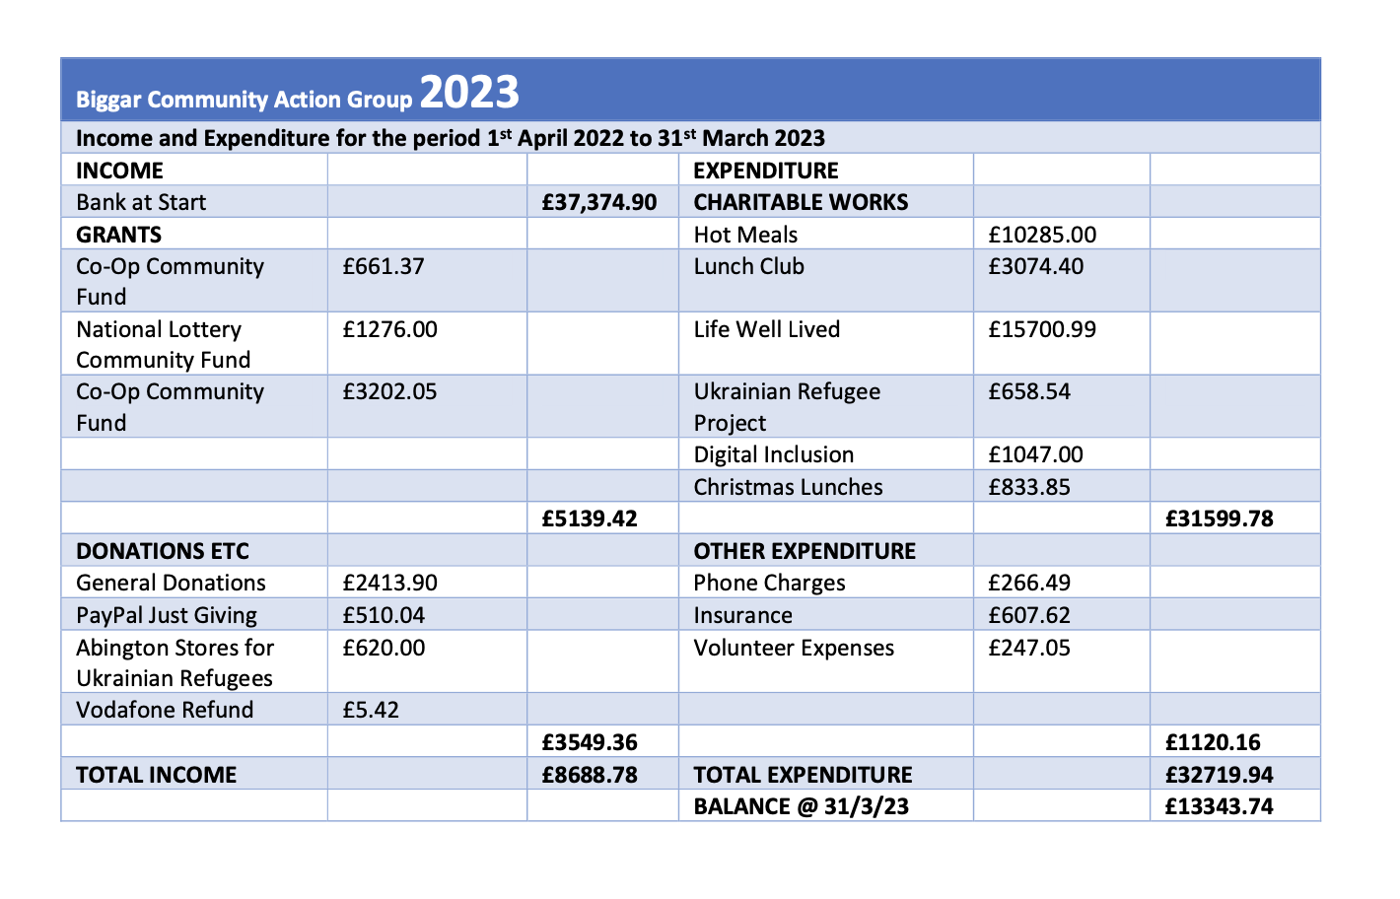
As there were no more questions the Chair thanked everyone for coming and brought the AGM to a close

Appendix 1

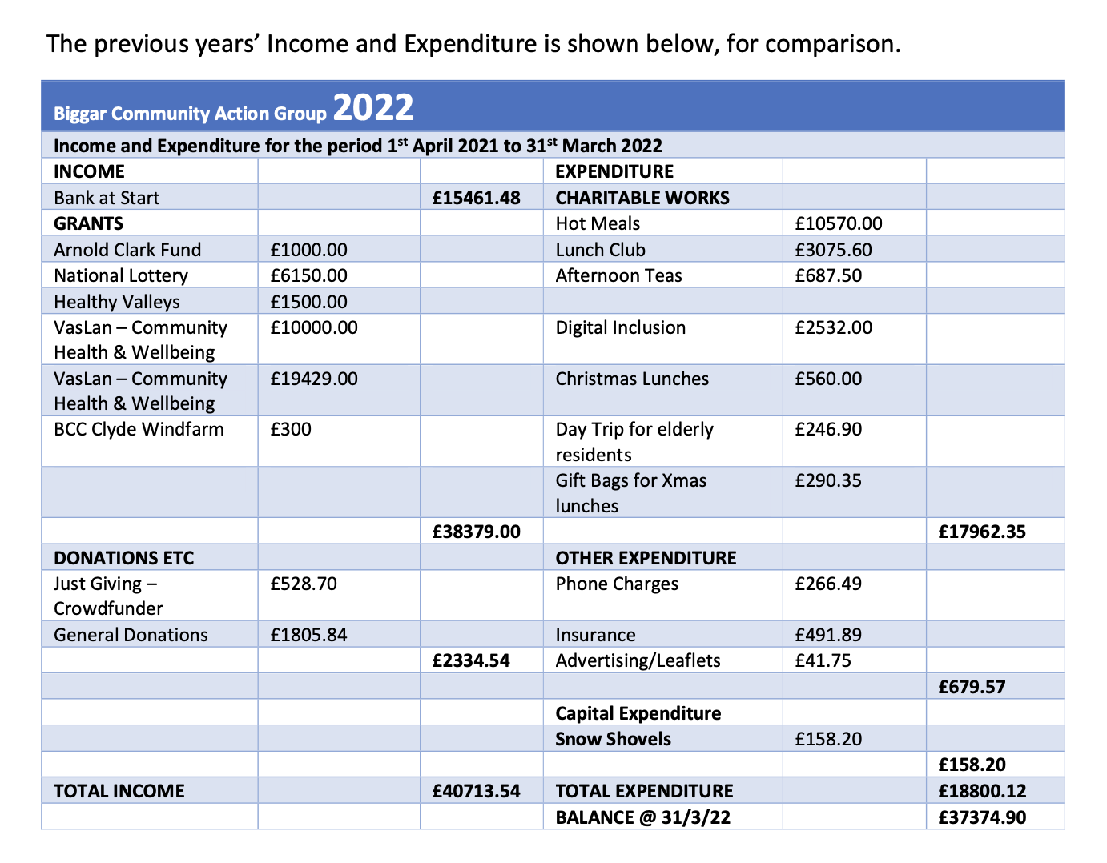
Appendix 2

Appendix 3

